**QUIZ SYSTEM**

**QUESTION:**

Draw a Use case diagram to model for a quiz system. A user can request a quiz for the system. The system picks a set of questions from its database, and composes them together to make a quiz. It rates the user’s answers and gives hints if the user requests it. In addition to users, we also have helpers who provide questions and hints. And also, administrators who must certify questions to make sure they are not too trivial, and that they are correct  
**AIM:**To develop a Use Case Diagram for a Quiz System that allows users to take quizzes, request hints, and enables helpers to provide questions while administrators certify them.

**PROCEDURE:**

1. Identify system functionalities: quiz creation, answer evaluation, hint request, question certification.

2. Define interactions like quiz request, question selection, and hint provision.

3. Structure system processes and relationships.

4. Draw the Use Case Diagram representing these functionalities.

**DIAGRAM:**

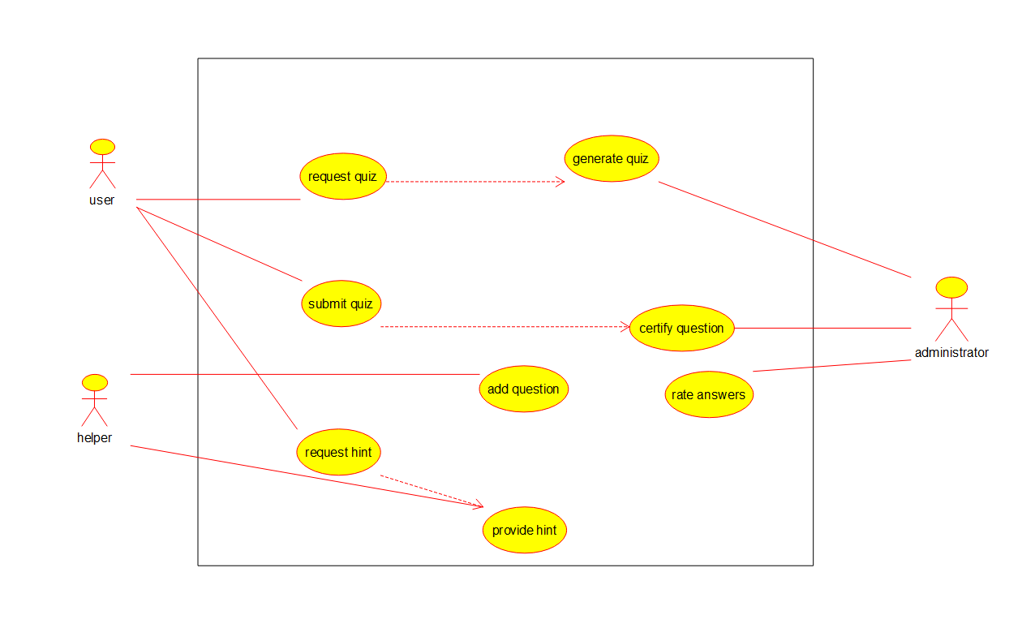

**RESULT:**

A **Use Case Diagram** for the **Quiz System** was successfully created.